JAVA ASSIGNMENT 1

**NAME** : MIHIR RAJESH PANCHAL

**SAP ID** : 57498200018

**ROLL NO** : T018

**SEM** : III (INFORMATION TECHNOLOGY)

**SUBJECT** : PROGRAMMING IN JAVA

|  |  |  |
| --- | --- | --- |
| INDEX | | |
| SR.NO | TITLE (Problem Statement) | REMARKS |
| 1 | Write a Java program that reads two integers, determines whether the first number is a multiple of the second and prints the result. |  |
| 2 | To check whether entered number is a perfect square or not. |  |
| 3 | Write a program that inputs n numbers and determines and prints the number of negative numbers, the number of positive numbers and the number of zeros. |  |
| 4 | Define a class Employee having data members as specified in the given diagram. Write a Java program for n number of employees as per given scenario. |  |

1. Write a Java program that reads two integers, determines whether the first number is a multiple of the second and prints the result.

**Source Code :**

import java.util.Scanner;

class Multiple

{

public static void main(String args[])

{

Scanner sc=new Scanner(System.in);

System.out.print("Enter Number 1 : ");

int num1=sc.nextInt();

System.out.print("Enter Number 2 : ");

int num2=sc.nextInt();

if(num2%num1==0)

{

System.out.println(num1+" is multiple of "+num2);

}

else

{

System.out.println(num1+" is not multiple of "+num2);

}

}

}

**Output :**

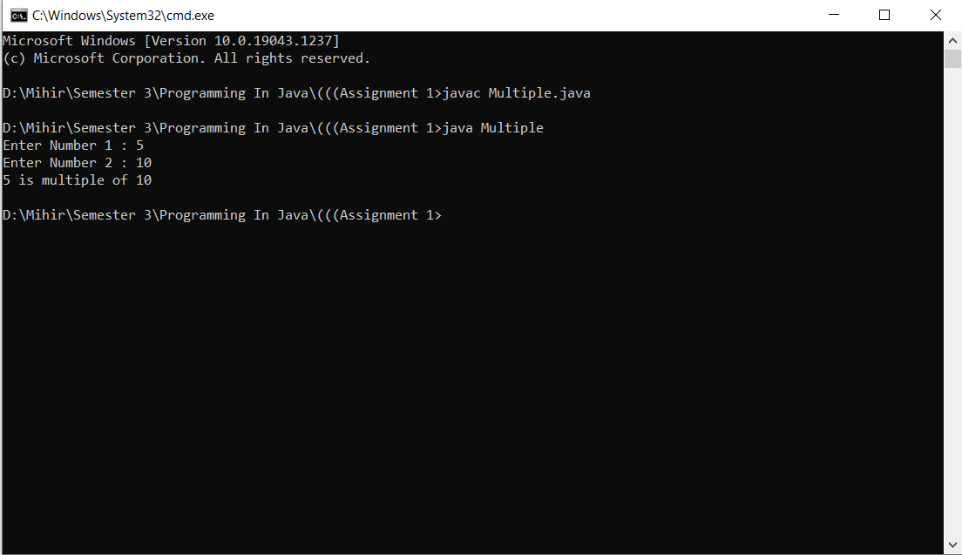

2. To check whether entered number is a perfect square or not.

**Source Code :**

import java.util.Scanner;

class SquareCheck

{

public static void main(String args[])

{

Scanner sc = new Scanner(System.in);

int i=0,flag=0;

System.out.print("Enter the Number : ");

int num=sc.nextInt();

for(i=0;i<num;i++)

{

if(i*i==num)

{

System.out.println("Entered Number "+num+" is a perfect Square ");

System.out.println(+num+" is Square of "+i);

flag=0;

break;

}

else

{

flag=1;

}

}

if(flag==1)

{

System.out.println("Entered Number "+num+" is not a perfect Square ");

}

}

}

**Output :**

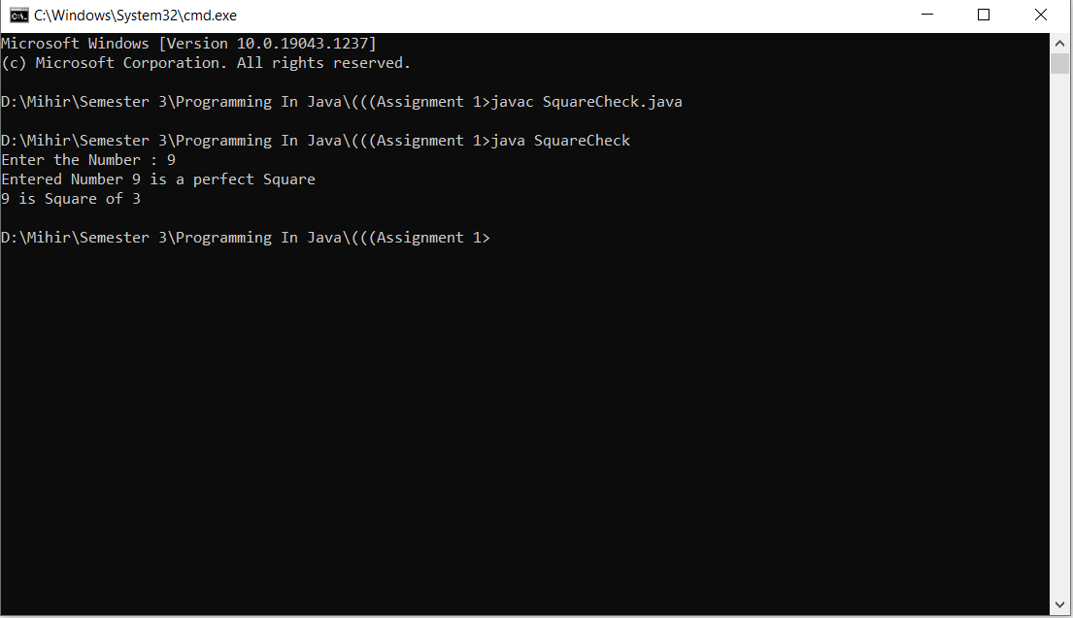

3. Write a program that inputs n numbers and determines and prints the number of negative numbers, the number of positive numbers and the number of zeros.

**Source Code :**

import java.util.Scanner;

class NumberCount

{

public static void main(String args[])

{

Scanner sc = new Scanner(System.in);

int i,num,cn=0,cz=0,cp=0,n;

System.out.print("Enter Number of Elements : ");

n=sc.nextInt();

for(i=1;i<=n;i++)

{

System.out.print("Enter Number "+i+" : ");

num=sc.nextInt();

if(num<0)

{

cn=cn+1;

}

else if(num==0)

{

cz=cz+1;

}

else

{

cp=cp+1;

}

}

System.out.println("Count of Negative Numbers : "+cn);

System.out.println("Count of Zero : "+cz);

System.out.println("Count of Positive Numbers : "+cp);

}

}

**Output :**

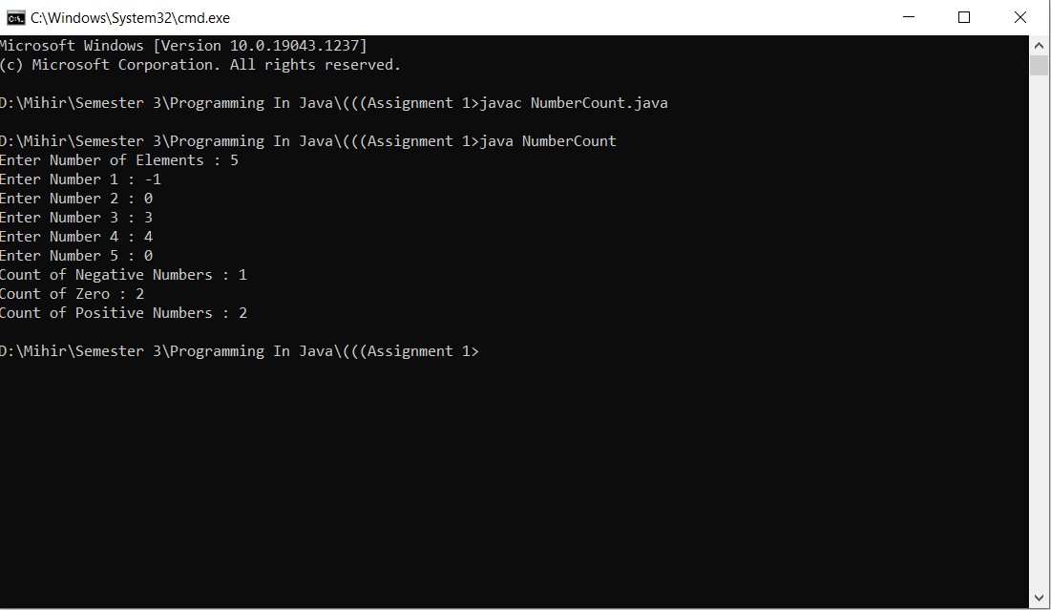

4. Define a class Employee having data members as specified in the given diagram. Write a Java program for n number of employees as per given scenario.

**Source Code :**

import java.util.Scanner;

class Employee

{

String jobnumber;

int level,ca,ea;

float bsal,hra,gsal,tgsal;

void setEmployee()

{

Scanner sc=new Scanner(System.in);

System.out.print("Enter the Job Number : ");

jobnumber=sc.nextLine();

System.out.print("Enter the Level Number : ");

level=sc.nextInt();

System.out.print("Enter the Basic Pay : ");

bsal=sc.nextFloat();

}

void evaluation()

{

if(level==1)

{

ca=1000;

ea=500;

}

else if(level==2)

{

ca=750;

ea=200;

}

else if(level==3)

{

ca=500;

ea=100;

}

else if(level==4)

{

ca=250;

ea=0;

}

hra=(25*bsal)/100;

gsal=bsal+ea+ca+hra;

if(gsal<=2000)

{

tgsal=gsal;

}

else if(gsal>2000&&gsal<=4000)

{

tgsal=gsal-((3*gsal)/100);

}

else if(gsal>4000&&gsal<=5000)

{

tgsal=gsal-((5*gsal)/100);

}

else if(gsal>5000)

{

tgsal=gsal-((8*gsal)/100);

}

}

void getEmployee()

{

System.out.println("\nJob Number : "+jobnumber);

System.out.println("Level Number : "+level);

System.out.println("Basic Pay : "+bsal);

System.out.println("Conveyance Allowance : "+ca);

System.out.println("Entertainment Allowance : "+ea);

System.out.println("House Rent Allowance : "+hra);

System.out.println("Gross Salary Before Tax Deduction : "+gsal);

System.out.println("Income Tax : "+(gsal-tgsal));

System.out.println("Gross Salary : "+tgsal);

}

}

class EmployeeMain

{

public static void main(String args[])

{

Scanner sc=new Scanner(System.in);

int size;

System.out.print("Enter The Number of Employee : ");

size=sc.nextInt();

Employee e[]=new Employee[size];

int i;

for(i=0;i<size;i++)

{

System.out.println("\nEmployee "+(i+1));

e[i]=new Employee();

e[i].setEmployee();

e[i].evaluation();

e[i].getEmployee();

}

}

}

**Output :**

